How to perform below operation in single execute SQL task.

1.Create table

**CREATE** **TABLE** LV_STUDENTS

(

STD_ID **INT**,

STD_NAME **VARCHAR**(100),

STD_AGE **INT**,

STD_CITY **VARCHAR**(50),

STD_MOB **VARCHAR**(12)

)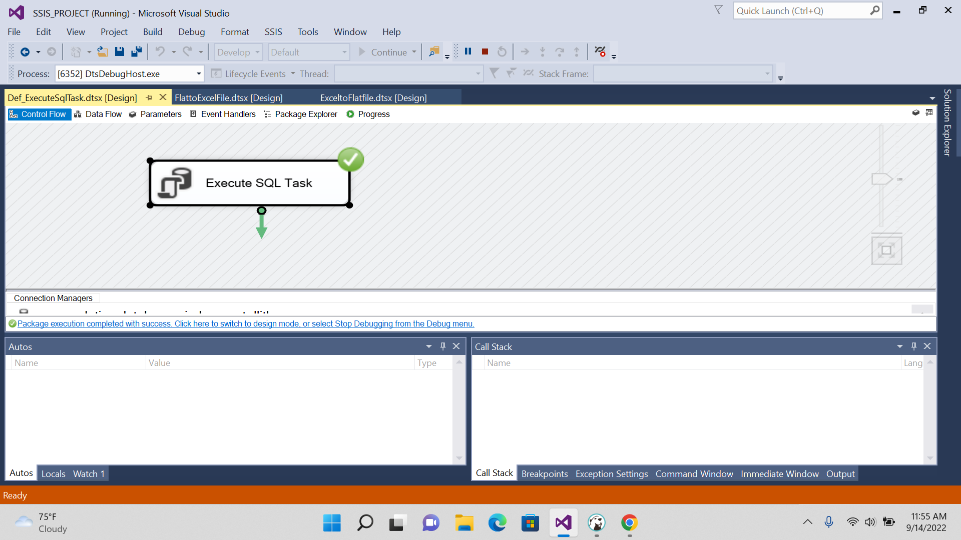

2.Insert data

**INSERT** **INTO** LV_STUDENTS **VALUES**(100,'ANAGHA',22,'BANGALORE','1324536572')

**INSERT** **INTO** LV_STUDENTS **VALUES**(101,'ANANYA',21,'MANGALORE','1324538792')

**INSERT** **INTO** LV_STUDENTS **VALUES** (102,'BHAVANA',20,'BANGALORE','9024536572')

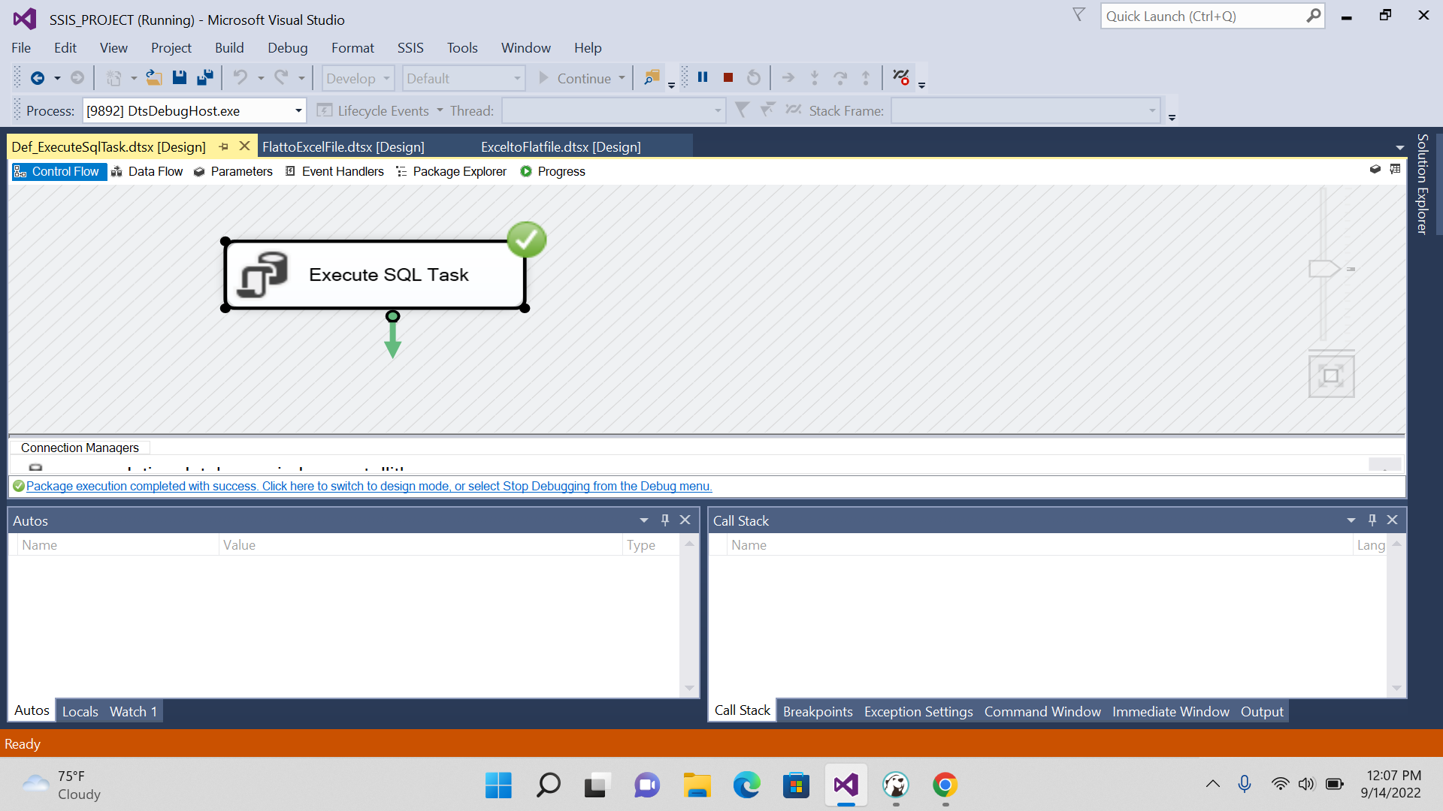

3.Update data.

**UPDATE** LV_STUDENTS

**SET** STD_NAME='KEERTHANA'

**WHERE** STD_ID=100

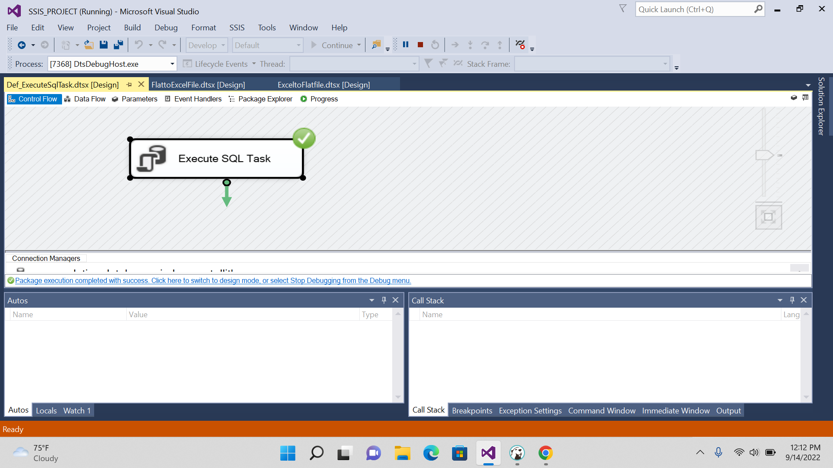

4.Delete any one row.

**DELETE** **FROM** LV_STUDENTS

**WHERE** STD_ID=100

6. Truncate table.

**TRUNCATE** **TABLE** LV_STUDENTS

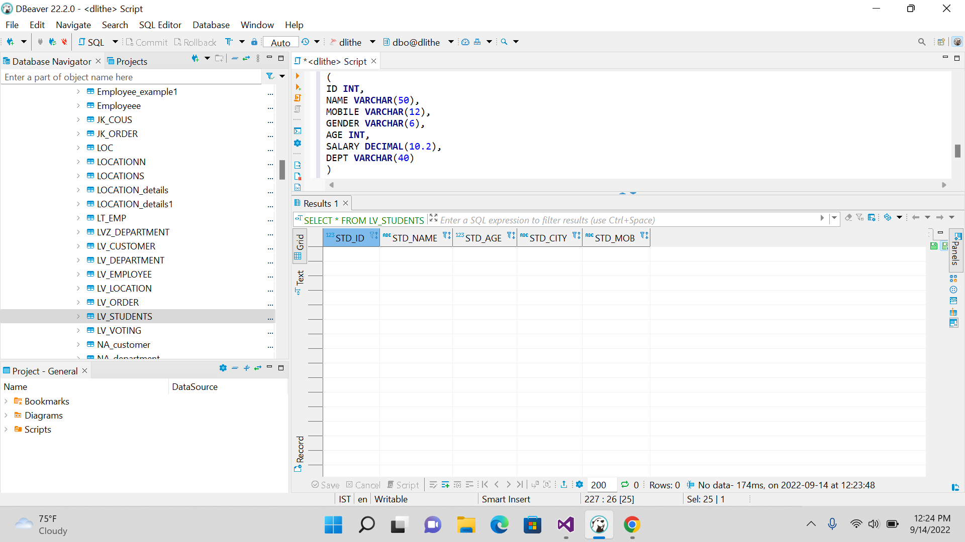

7. Drop table.

**DROP** **TABLE** LV_STUDENTS



